Project Report:Virtual Networking Lab for TechSol Ltd.

Scenario Description
TechSol Ltd. is establishing a new office requiring a reliable internal network for seamless communication, resource sharing, and internet access.As the junior network engineer, my objective is to design, implement, and test a basic network setup, including Engineering and HR departments, a centralised Server room and a shared Internet Gateway.This network will include server services like DNS, Web Server and File Server capabilities.
Objectives
Build and configure a functioning office network.
Ensure inter-department communication across subnets.
Enable server services (Web,DNS,FTP) for centralised resource access.
Test and troubleshoot connectivity issues.
Apply the OSI model to ensure proper network operations
Network Layout
Devices:
- 1 Routers
- 2 Switches
- 6 PCs (3 per department)
- 1 Server
- 1 Router (for internet simulation instead of cloud)
- Appropriate cabling (Copper Straight-Through )
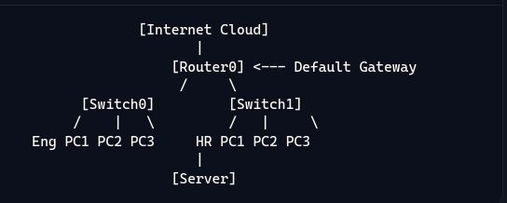
Implementation Steps
1.Basic Configuration
Engineering Department(VLAN 10)
Subnet:10.20.10.0/24
Default Gateway:10.20.10.254
Router Sub Interface:GigabitEthernet0/1.10 or GigabitEthernet0/0.10
HR Department(VLAN 20)
Subnet:10.10.10.0/24
Default Gateway:10.10.10.254
Router Sub Interface:GigabitEthernet0/1.20
Configure Router interfaces:
Router0 connects to the Internet via a router with NAT-enabled interface.
2.Server-Setup
Enable services on the server
HTTP(WEB)
DNS
FTP(File Sharing)
Assign Server IP:10.10.10.0/24
Configure DNS records:Intranet.techsol.local pointing to 10.10.10.10
3.Routing Configuration
To enable communication between the different subnets(HR,Engineering and Server ),static routing was implemented.
On Router0(the edge router connected to the simulated Internet),static routes were added to reach the internal subnets via Router1:
ip route 10.10.10.0 255.255.255.0 192.168.10.2
ip route 10.20.10.0 255.255.255.0 192.168.10.2
On Router1(the internet router), a default route was added to send all unknown traffic(e.g., Internet-bound traffic) to Router0.
ip route 0.0.0.0 0.0.0.0 192.168.10.1
This configuration enables full inter-subnet routing and allows devices to reach external networks through NAT on Router0
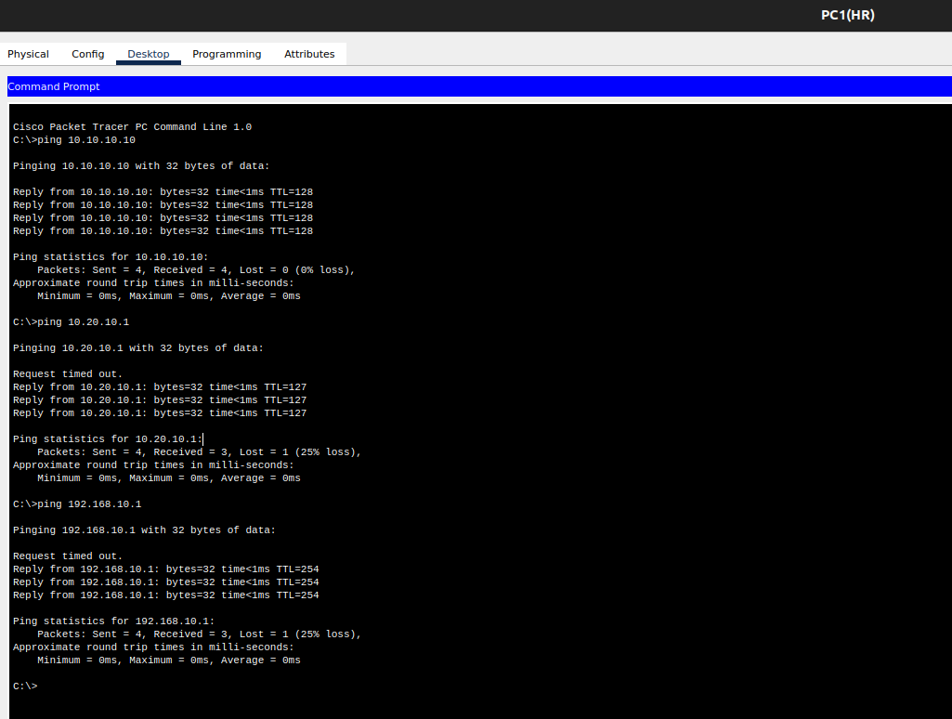
4.DNS Resolution
Set the DNS configurations on all PC’s to point to the server(10.10.10.10)
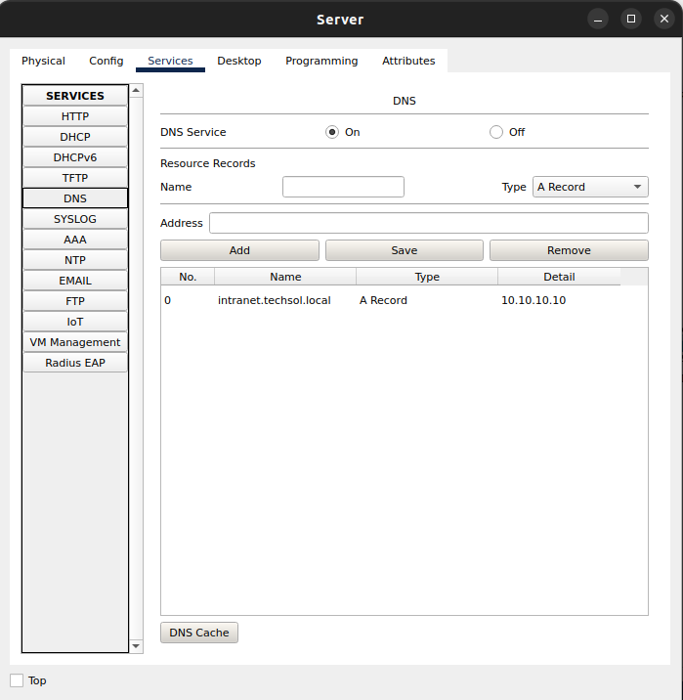
Test the DNS by accessing http://intranet.techsol.local via a web browser.
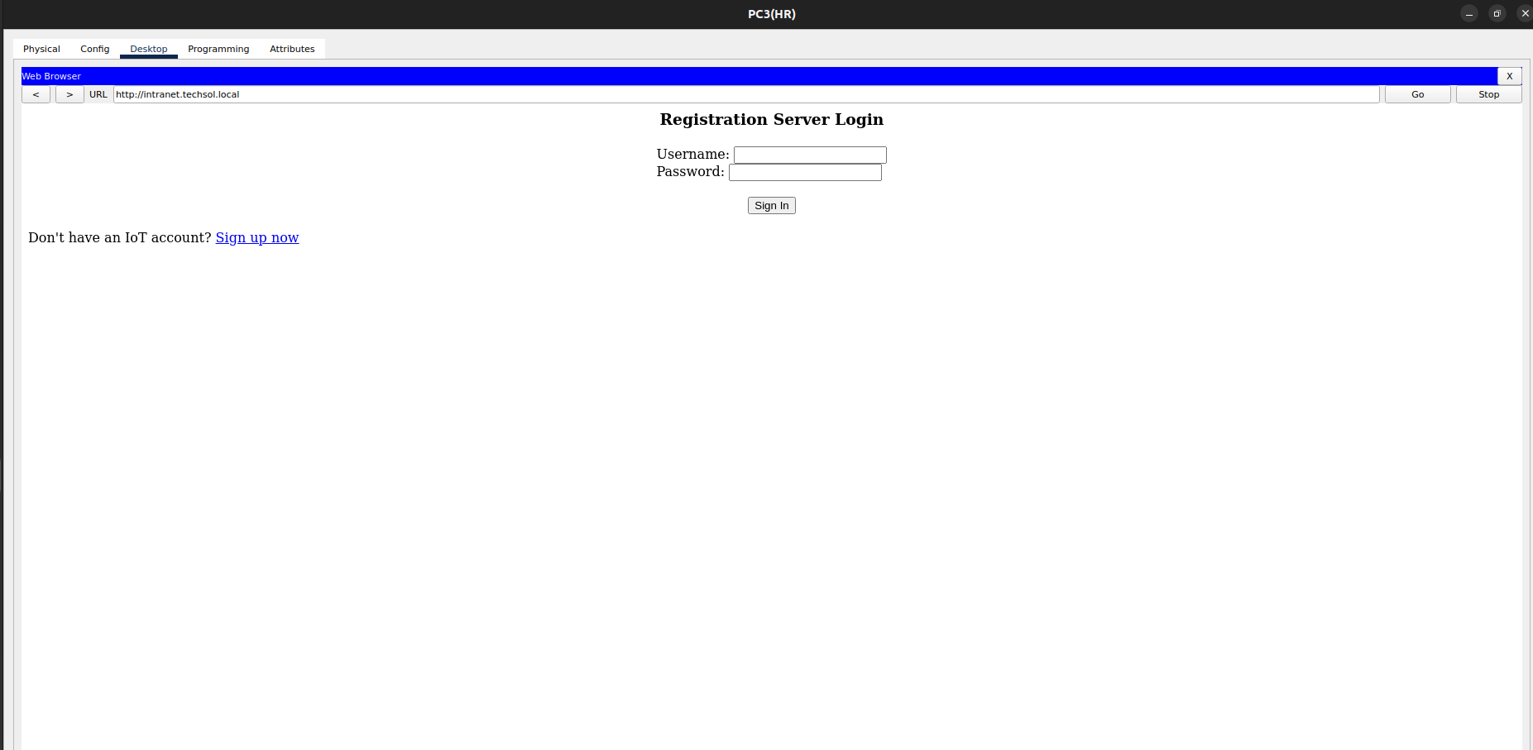
5.File Transfer
Perform FTP tasks:
Connect to the server using FTP client commands.
.
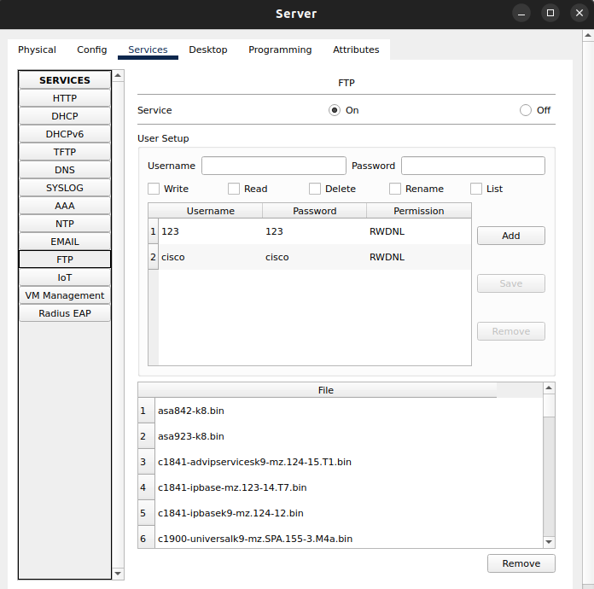
Transfer a test file to verify FTP service.
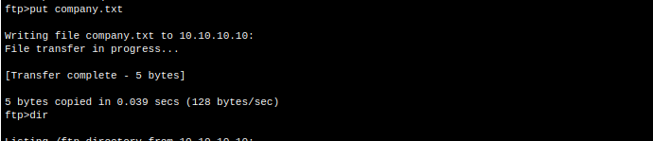
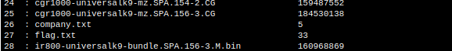
6.Internet Simulation
Configure NAT on Router 0 for external Internet access.
access-list 1 permit 10.0.0.0 0.255.255.255
ip nat inside source list 1 interface GigabitEthernet0/1 overload
interface GigabitEthernet0/0
ip nat inside
interface GigabitEthernet0/1
ip nat outside
External Internet Router Configuration:
interface GigabitEthernet0/0
ip address 200.0.0.2 255.255.255.0
no shutdown
Ip route 10.10.10.0 255.255.255.0 200.0.0.1
ip route 10.20.10.0 255.255.255.0 200.0.0.1
Test connectivity to a mock external IP(8.8.8.8) via ping
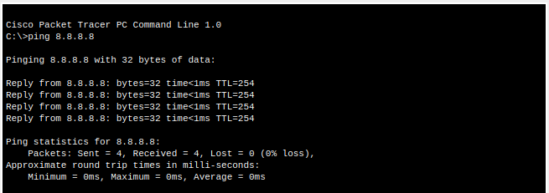
7. Testing & Verification
Use diagnostic tools:
1.ping
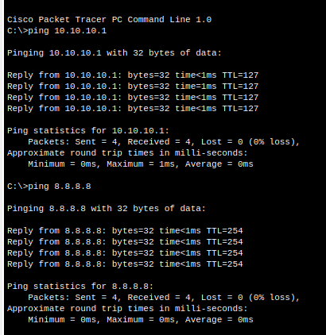
2.tracert
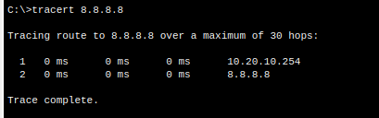

3.nslookup
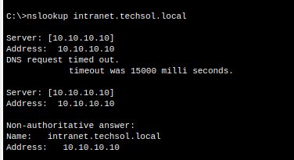
4.FTP
*Already shown above
5.Web
